**Exercise 1: Project Bootstrapping**

### **Objective:** Set up a new Python project with a README, a main application file (main.py), and a test file (test_main.py).

## **Step-by-Step Instructions**

### **Set Up Your Environment**

* 1. **Sign In to GitHub:**
     1. Open your browser, navigate to [github.com](http://github.com), and sign in (or sign up if needed).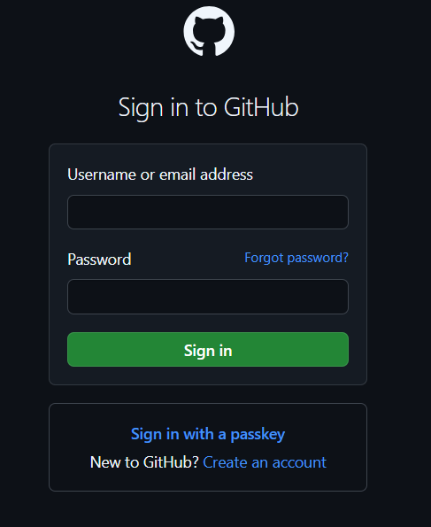
  2. **Install VS Code and GitHub Copilot Extension**:
     1. Download and install Visual Studio Code.
     2. Open VS Code.
     3. Click on the Extensions icon (or press Ctrl+Shift+X).
     4. Search for “**GitHub Copilo**t” and click “**Install**.”

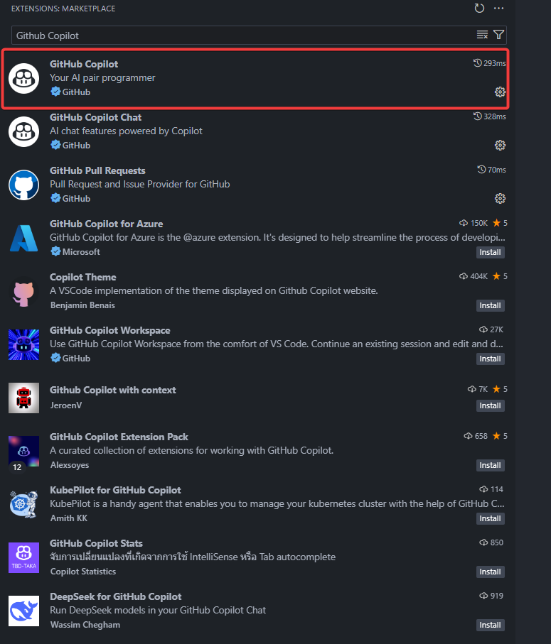

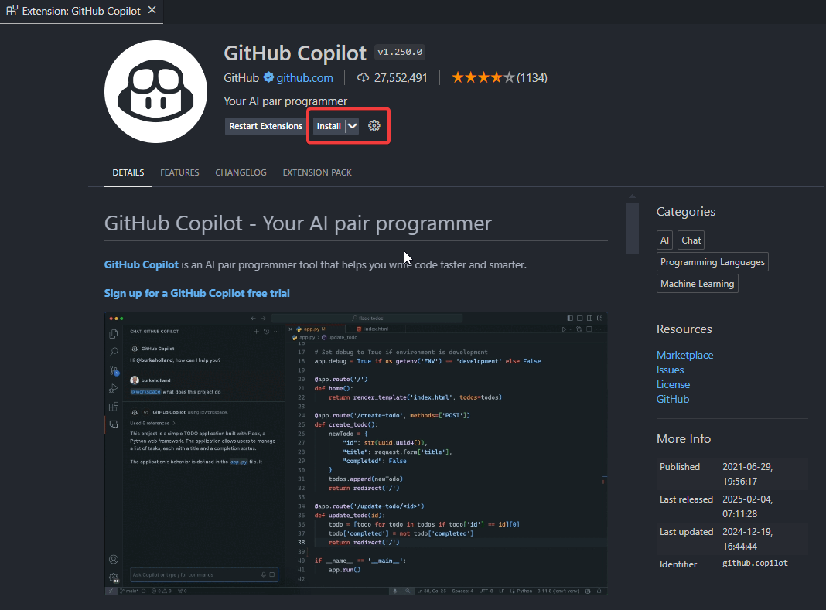

* + 1. After installation, follow the prompts to sign in to GitHub via Copilot.

### **Create a New Project Folder**

* 1. Create a folder on your computer called MyCopilotPythonProject.
  2. In VS Code, click **File** > **Open Folde**r… and select the folder you just created.

### **Create a README File**

* 1. In the VS Code Explorer, click “**New File**.”
  2. Name the file **README.md**
  3. Type a comment like:

|  |
| --- |
| <!-- Describe your Python project here --> |

* 1. If GitHub Copilot suggests a paragraph or template, press Tab to accept the suggestion.
  2. Save the file (Ctrl+S).

### **Create the Main Application File**

* 1. In your project folder, create a new file named main.py.
  2. At the top of main.py, type a comment:

|  |
| --- |
| #main file containing code for a function for performing basic mathematical operations |

* 1. Allow Copilot to show you suggestions (for example, a basic function or a “Hello, World!” snippet). Accept any helpful suggestions by pressing Tab.

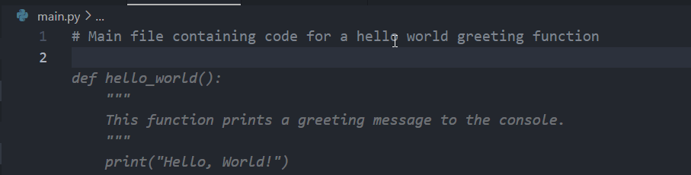

* 1. Save the file.

### **Create the Test File**

* 1. Create another file named test_main.py.
  2. Start with a comment indicating the purpose:

|  |
| --- |
| #Test cases for functions in main.py |

* 1. Type a simple comment such as:

|  |
| --- |
| #Write a test for a simple greeting function |

* 1. Watch for Copilot suggestions; if you see a recommended test function, press Tab to accept it.

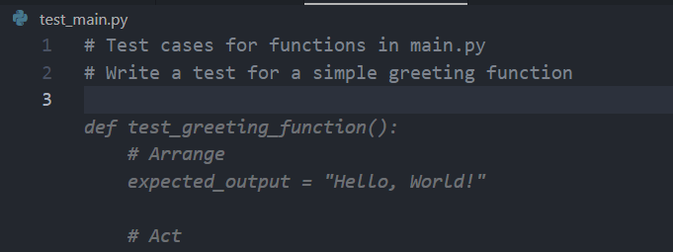

* 1. Save the file.

### **Initialize a Git Repository**

* 1. Open the terminal in VS Code (View > Terminal or press Ctrl+`).
  2. Run the following commands:

|  |
| --- |
| git init git add . git commit -m "Initial project bootstrapping for Python" |

### **Verify Your Setup**

* 1. Open any of your files (e.g., main.py) and start typing. GitHub Copilot should display suggestions.
  2. If not, ensure the Copilot extension is enabled and you’re signed in.

Voila!! We have successfully completed this exercise.